Experiment : 07

GRANT SELECT ON BANK_56 TO c24csa55;
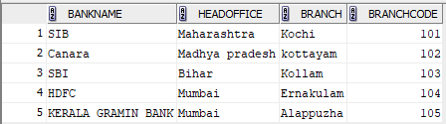

revoke select on Bank_56 from C24csa55;

Experiment : 08

Create Table Bank2_56(
Bankcode Varchar(3) Primary Key,
Bankname Varchar(50) Not Null,
Headoffice Varchar(50),
Branches Int Check (Branches>0)
);
Insert Into Bank2_56 Values('SBI','State Bank of India','Mumbai',20000);
Insert Into Bank2_56 Values ('HDF', 'HDFC Bank', 'Kottayam', 6000);
Insert Into Bank2_56 Values ('ICI', 'ICICI Bank', 'Mumbai', 5000);
Insert Into Bank2_56 Values ('PNB', 'Punjab National Bank', 'New Delhi', 10000);
Insert Into Bank2_56 Values ('CAN', 'Canara Bank', 'Ernakulam', 9000);
insert into Bank2_56 Values ('KGB','Kerala Gramin Bank','Ernakulam',2000);

CREATE TABLE Branch2_56 (
branchid INT PRIMARY KEY,
branchname VARCHAR(50) DEFAULT 'New Delhi',
Bankid Varchar(3),
FOREIGN KEY (branchid) REFERENCES Bank2_56(Bankcode)
);
Insert Into Branch2_56 Values (1, 'Kochi', 'SBI');
Insert Into Branch2_56 Values (2, 'Ernakulam', 'HDF');
Insert Into Branch2_56 Values (3, 'Chennai', 'ICI');
Insert Into Branch2_56 Values (4, 'Delhi', 'PNB');
Insert Into Branch2_56 Values (5, 'Bangalore', 'CAN');
Insert Into Branch2_56 Values (6, 'New Delhi', 'KGB');

- Create a View named bank_head office to hold the details of all bank whose head
office at Ernakulam.

Create View Bank_Head_Office As Select * From Bank2_56 Where Headoffice='Ernakulam';
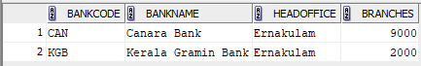
- Create a View named bank_branch to hold the details of all bank who have branches
at kottayam.

Create View Bank_Branch As Select Distinct B.* From Bank2_56 B Join Branch2_56 Br On B.Bankcode=Br.Bankid Where Br.Branchname='Kottayam';
- Create a View to show banks with more than 50 branches

Create View Bank_More_Than_50 As Select * From Bank2_56 Where Branches>50;

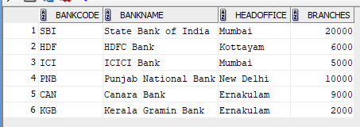

- Create a View to display bank name and branch name

Create View Bank_Branch_Details As Select B.Bankname, Br.Branchname From Bank2_56 B Join Branch2_56 Br On B.Bankcode=Br.Bankid;

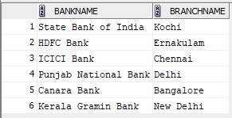

- Create a View to show banks located outside Ernakulam

Create View Bank_Outside_Ernakulam As Select * From Bank2_56 Where Headoffice<>'Ernakulam';

